# 1.Machine Learning 101

## What is Machine Learning?

Ans: The goal of machine learning is to make machines act like more and more like humans.

Machine learning is using an algorithm or computer program to learn about different patterns in data and then taking those patterns to make predictions about the future using similar data. The machine learning is also known as **models.**

The machine learning algorithms, looks at the input and then at the output and then tries to figure out instructions, in between these two.

## AI/Machine Learning/ Data Science

**AI (Artificial Intelligence):** It means a human intelligence exhibited by the machines. An AI is a machine that acts like a human.

* Narrow AI: These machines can do only one task really well.
* General AI: They have multiple abilities and can perform multiple tasks.

**Machine Learning** is a subset of AI. It is an approach to achieve AI through systems that can find patterns in a set of data**. It is a science to getting computers to act, without being explicitly programmed.**

**Deep Learning** is one of the techniques to implement machine learning.

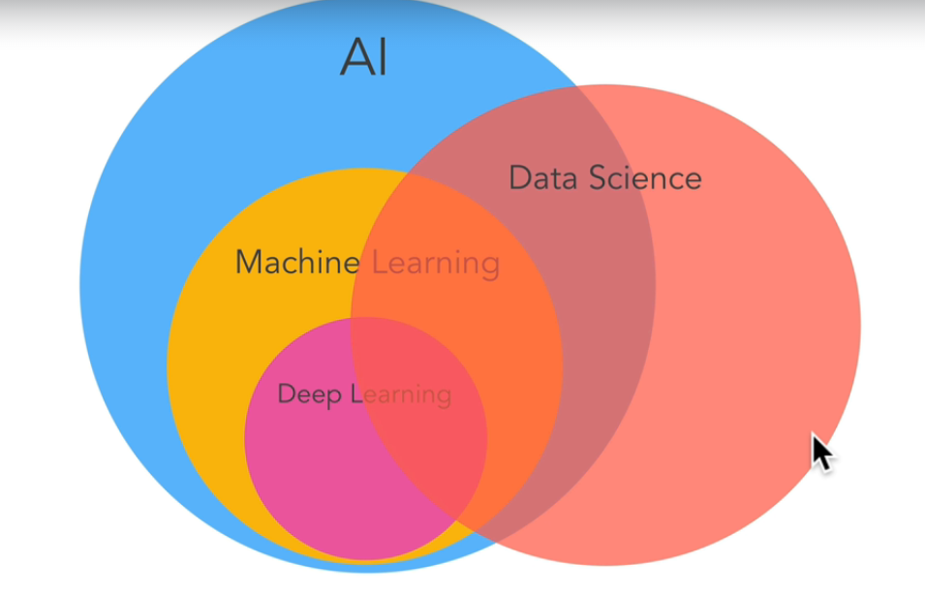

## Types of Machine Learning

**Supervised Learning, Unsupervised Learning and Reinforcement Learning**

# 2.Machine Learning and Data Science Framework

## Introduction to the Framework

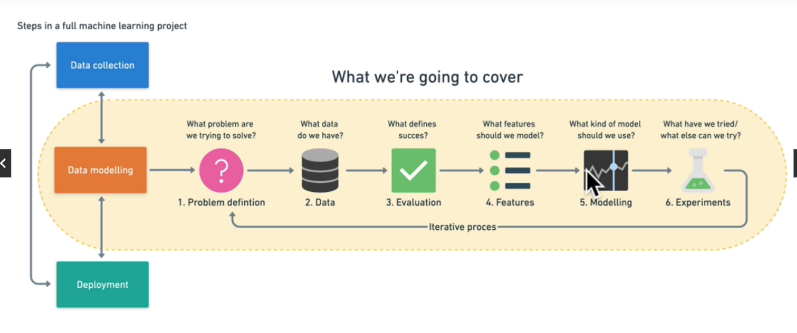

## Types of Machine Learning problems

1. Problem Definition.

When not to use Machine learning:

* Will a simple hand coded problem work?

### Supervised Learning:

The supervised learning has both data and the labels. A machine learning algorithm tries to use the data and then predict the label. If the prediction is wrong, the algorithm corrects the algorithm and tries algorithm again.

The main types of supervised learning are **classification problems and regression problems.**

**Classification:** The classification involves predicting if something is one thing or the other. If only two class are present it is known as binary classification. If there are multiple classes are present, it is known as multi-class classification problems.

**Regression:** It involves trying to predict a continuous number.

### Unsupervised Learning:

Unsupervised learning has data but no labels.

Example clustering

### Transfer Learning

It leverages what one machine learning has learnt in another model.

### Reinforcement Learning

It is about performing actions in a defined space and rewarding it for correct actions and punishing it for wrong actions.

## Types of Data

### Structured data:

It contains rows and columns which has data in it.

### Unstructured data:

It does not have specific structure and contains text, images and audio files.

### Static data

The static data does not change over time.

### Dynamic data